Reinforcement Learning Maze Solver Using Q-Learning

Topic, I Chose
For my machine learning project, I chose Reinforcement Learning, and more specifically the Q-learning algorithm. I picked this topic because it is one of the simpler reinforcement learning methods to start with, but it still shows real artificial intelligence behavior. Reinforcement learning is used in many real-world systems, such as games, AI agents, robotics, and navigation tasks. I wanted to try something that feels like “real AI,” not just basic if else logic.
My program uses Q-learning to teach an agent to solve a randomly generated maze. The maze has walls, open spaces, a starting point labeled A, and a goal labeled G. The agent begins at A and learns, through trial and error, how to reach G using the shortest and safest path. I did not hard code the correct path. Instead, the agent learns by receiving rewards and penalties based on where it moves.

How Reinforcement Learning Works
Reinforcement learning is a type of machine learning where an agent interacts with an environment, receives feedback, and improves over time. The agent chooses an action, the environment responds with a reward, and the agent updates its strategy. The process directs the agent to “discover which actions yield the most reward” by trial and error. In my project, the environment is the maze, and the agent is the program that moves around inside it.
In my maze, the agent can move Up, Right, Down, or Left. The maze uses characters to represent the environment: # for walls, for open spaces, A for the start, and G for the goal. The reward system in my code is simple:
- + 50 for reaching the goal
- − 1 for each valid step
- − 5 for trying to walk into a wall
This reward logic is implemented in the apply Action function in my code (around lines 96–119). For example, when the agent hits a wall, the code does: (-5.0 Points)
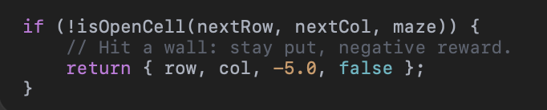
This appears around line 104 in my C++ file. When the agent reaches the goal, it gets a big positive reward: (+ 50 points)
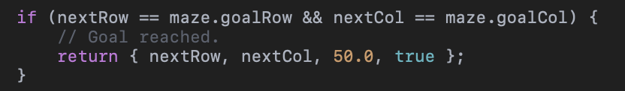
This is around line 108. Any normal valid move that does not reach the goal and does not hit a wall returns a smaller negative reward: (-1.0 Points for each step)
These rewards encourage the agent to find a short path (because steps cost −1) and avoid banging into walls (because that costs −5).
How Q-Learning Works and Where It Appears in My Code
Q-Learning is a type of reinforcement learning where an agent learns by trial and error. The agent receives rewards for good actions and penalties for bad actions. The goal is to learn which actions lead to the best long-term results. Q-Learning does this by keeping a table called a Q-table, where each cell stores how good it is to take a certain action in a certain state. Every time the agent moves in the maze, it updates this table using the Q-Learning formula. Over many training runs, the agent learns which direction to move to reach the goal in the shortest path.
The main Q-learning update formula is:
Q (s, a) = oldQ + learningRate × (reward + discount × maxNextQ – oldQ
In my code, this formula is implemented inside the training loop in the trainAgentWithQLearning function (around lines 215–239). The exact line that updates the Q-value is:
Variables and their purpose:
- oldQ → the current knowledge the agent has
- learningRate (α) → how fast the agent learns
- mv.reward (r) → the score the agent receives for the action
- discountFactor (γ) → how important future rewards are
- maxNextQ → the best possible future reward from the next step
The Q-table itself is created in main, where I calculate the number of states and actions, this is around line 234
Exploration vs. Exploitation (ε-Greedy Policy)
If the agent always picks the best move it currently knows, it might get stuck in a bad habit and never discover better paths. To avoid this, I used an ε-greedy strategy, which I learned from a GeeksforGeeks article on exploration vs. exploitation. In ε-greedy, the agent sometimes takes random actions (exploration) and sometimes picks the best-known action (exploitation).
In my code, this logic lives in the choose Action function (around lines 121–146):
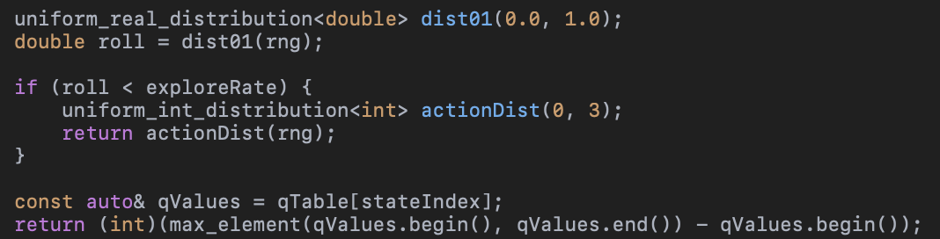
This section shows exactly how the ε-greedy idea is implemented:
- With probability exploreRate (ε), the agent picks a random action.
- Otherwise, it returns the action with the highest Q-value for the current state.
so, the agent explores more at the beginning and exploits more toward the end.

What My Program Computes – Inputs and Outputs
My program computes the fastest path the agent learns in a randomly generated maze and summarizes how the training went. It produces several text files and also prints information in the terminal.
Inputs
- The user enters a maze size like "6x10" when the program starts.

Outputs
- maze.txt – the internal character grid of the generated maze
- final_path.txt – the ASCII maze with the learned fastest path marked
- training_stats.txt – a summary of attempts, successful runs, and the fastest path steps
The program also interacts with the user by asking questions in the terminal, such as whether to show the generated maze, the training summary, the exact path as dots, and the step-by-step moves. All of these prompts use the ask Yes or No function defined near the top of the file
How the Program Works
Here is the main algorithm of my program:

Step 1: Generate a Random Maze
- A maze with walls (#), open spaces (.), a start (A), and a goal (G) is created.
- A path from A to G is guaranteed by using Breadth-First Search (BFS)

Step 2: Initialize the Q-table
- A Q-table is created with one row for each maze cell and four columns (Up, Right, Down, Left).
- Everything starts at 0, meaning the agent knows nothing.

Step 3: Training Loop
The agent attempts the maze many times (500 in my program):
- Start at A
- Choose an action using the ε-greedy algorithm
  - Random move with probability ε (exploration)
  - Best known move with probability 1−ε (exploitation)
- Execute the move using applyAction()
- Receive a reward
- Update the Q-table using the Q-learning formula
- Continue until:
  - The goal is reached, Or the step limit is exceeded
The exploration rate ε, decreases slowly over time to encourage learning.

Step 4: Find the Best Path
Once training ends:
- The program replays the best action sequence found
- Marks each visited cell with * in the final maze
- Saves this as final_path.txt

Step 5: Optional User Output
The user is asked:
- If they want to see the ASCII maze
- If they want to see the fastest path (dots view)
- If they want the step-by-step action sequence

Works Cited:
GeeksforGeeks. “Epsilon-Greedy Algorithm in Reinforcement Learning.” GeeksforGeeks,
https://www.geeksforgeeks.org/epsilon-greedy-algorithm-in-reinforcement-learning/. Accessed 16 Nov. 2025.
Hasssanezzz. Visual-Maze-Solver. GitHub,
https://github.com/hasssanezzz/visual-maze-solver.Accessed 16 Nov. 2025.
Luengo, Cris. “Solving Mazes Using Image Analysis.” Cris Luengo Blog, 17 Apr. 2010,
https://www.crisluengo.net/archives/277/. Accessed 16 Nov. 2025.
Orzan, Nicole. Reinforcement-Learning-Maze. GitHub,
https://github.com/nicoleorzan/Reinforcement-Learning-Maze. Accessed 16 Nov. 2025.
Pullen, Walter D. “Maze Algorithms.” Think Labyrinth,
https://www.astrolog.org/labyrnth/algrithm.htm#solve. Accessed 16 Nov. 2025.
Spryn, Mitchell. “Solving a Maze with Q-Learning.” Mitchell Spryn Blog, 2020,
https://mitchellspryn.github.io/blog/2020/12/17/Q-Learning-Maze.html. Accessed 16 Nov. 2025.
Sutton, Richard S., and Andrew G. Barto. Reinforcement Learning: An Introduction. 2nd ed., MIT Press, 2018.
Terman37. RL_Maze_Solver. GitHub,
https://github.com/terman37/RL_Maze_Solver. Accessed 16 Nov. 2025.
Watkins, Christopher J. C. H., and Peter Dayan. “Q-Learning.” Machine Learning, vol. 8, no. 3–4, 1992, pp. 279–292.
https://link.springer.com/article/10.1007/BF00992698. Accessed 16 Nov. 2025.
ChatGPT for Tips and Help Writing Program.

